

Draft a Client Review Summary using Copilot in Word
Exercise Overview
In this exercise, you will use Microsoft 365 Copilot in Word to transform meeting notes from a client conversation into a clear, professional, and client-ready document.
Learning Objectives
By the end of this exercise, learners will be able to:
- Drafting content from scratch
- Refining tone and clarity
- Structuring content
- Rewriting text interactively
- Generating summaries and action items
- Asking Copilot questions about the document
Scenario Context
You are a financial advisor at Northwestern Mutual.
You recently completed a quarterly review meeting with a client and took informal notes during the discussion. Your goal is to create a client-facing summary document that:
- Clearly explains what was discussed
- Highlights key recommendations
- Lists next steps in a clear and reassuring way

Step 1 – Open a new Word document
- Open Microsoft Word
- Create a blank document
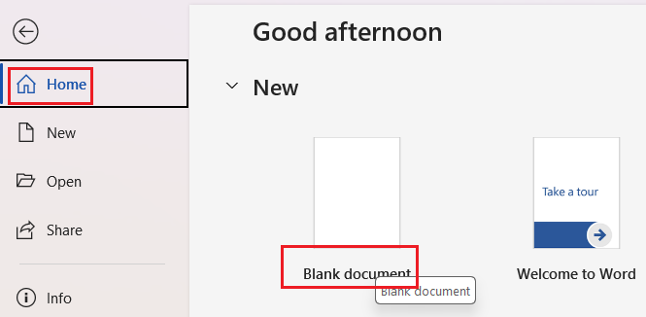
- Ensure Copilot is enabled
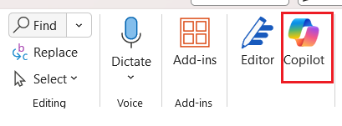

Step 2 – Paste the meeting notes
- Add the document Client_Meeting_Notes.docx to the chat context for copilot in word.
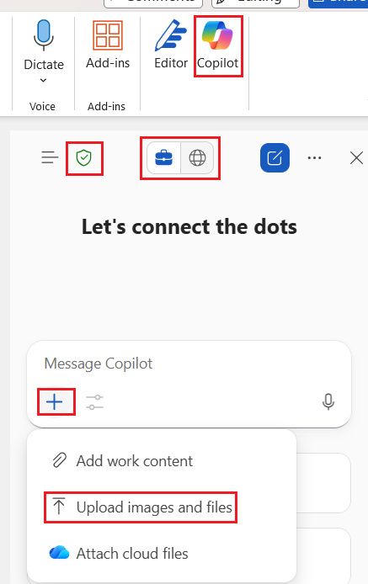

Step 3 – Draft the first version using Copilot
- Select Copilot and enter the following prompt:
Prompt 1: “Based on the attached document, draft a professional summary of a quarterly financial review meeting for a client. Use a clear, client-friendly and reassuring tone. Include an overview of financial goals, insurance coverage, retirement planning, and next steps.”
- Review the generated draft and Insert it into the document.
- Click on the pen icon.
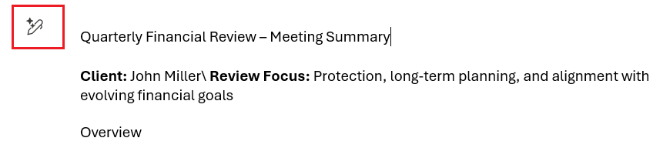
- Select Structure and refine.
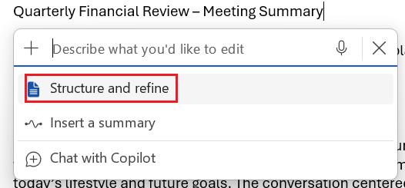
The "Structure and Refine" option in Copilot for Microsoft Word allows users to enhance the organization and clarity of their documents. When you select this feature, Copilot analyzes your content and suggests improvements to the flow, formatting, and overall structure: such as breaking up long paragraphs, adding headings, or clarifying transitions between sections. This helps ensure your document is well-organized, easy to read, and professionally presented.
Additionally, the "Refine" aspect focuses on polishing the language, correcting grammar, and improving word choice to make your writing more concise and impactful. Together, these options help you create documents that are both well-structured and clearly communicated, saving you time and effort during the editing process.
- Adjust tone for a client audience. Highlight the document and submit the following prompt:
Prompt 2: Adjust the tone of this document to sound more reassuring and suitable for a non-financial audience. Avoid technical jargon.
- Use the + button to add the output to your document
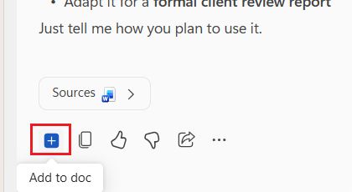
- Identify the Next Steps section
- Select the text
- Choose the Pen icon and then Visualize as a table
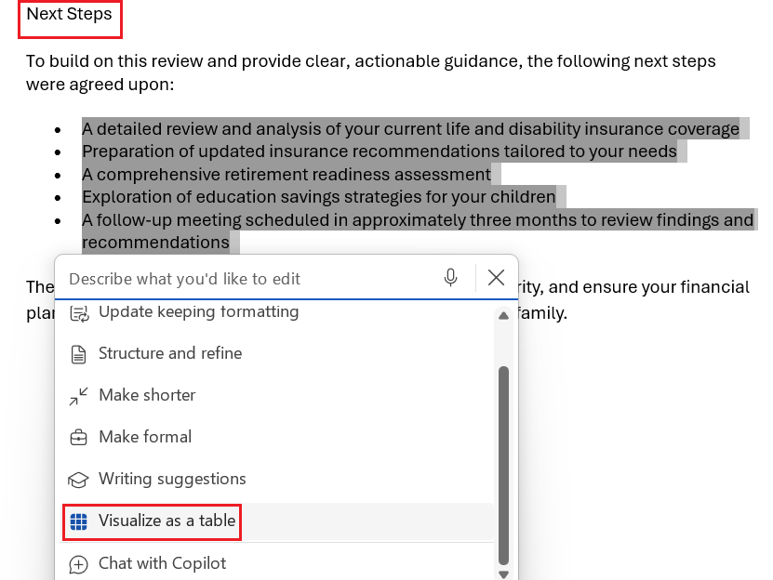
- Select Keep it or Replace depending on what you want to get in your document.
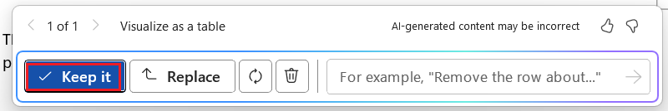
In Copilot for Microsoft Word, the "Keep it" and "Replace" options let you choose how to apply Copilot's suggested changes to your document. "Keep it" allows you to retain your original content and simply add Copilot's output alongside it, giving you both versions for comparison or further editing. On the other hand, "Replace" will substitute your original text with Copilot's suggestion, streamlining your document by only keeping the updated version. This flexibility helps you decide whether to integrate new ideas or maintain your existing work, making the editing process more tailored to your needs.
- Use the following prompt.
Prompt 3: “Transform the generated table by adding two new columns as follows: the owner of each action that represents the person in charge of it and a suggested timeline for each action.”
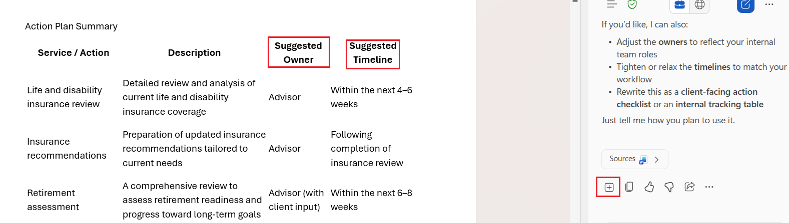
- Add a section to describe and define what is meant by success in the first 12 months in the new environment. This will provide hiring managers and candidates a concrete picture of success.
Prompt 4: “Create four professional, realistic images illustrating a financial advisor meeting with a client during a quarterly financial review. The setting is a modern, professional office environment with natural light. The advisor and client are seated at a table, reviewing financial documents such as charts, summaries, and action plans. The mood should be professional, calm, and trust-building. The visuals should reflect themes of financial planning, insurance review, retirement preparation, and family financial security. Avoid logos, brand names, or text on the images. Use a clean, corporate visual style suitable for a client-facing financial document. Generate four distinct image variations with different compositions and perspectives.”
- Insert the image in your document
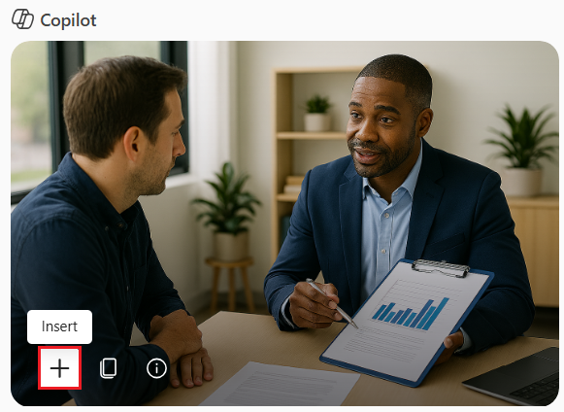
- Share the images you have generated in the chat.
- You can also ask copilot to generate the image and include the company’s logo.
Prompt 5: “Create one professional, realistic image illustrating a financial advisor meeting with a client during a quarterly financial review. The setting is a modern, professional office environment with natural light and a calm, trust-building atmosphere. The advisor and client are seated at a table reviewing financial documents such as a client review summary, charts, and a list of next steps related to insurance, retirement planning, and long-term financial security. Subtly include the company logo from the attached image in a natural and realistic way, such as on a document cover, folder, or discreet office element. Do not modify the logo. Do not exaggerate its size or prominence. Avoid any additional text, slogans, or brand names in the image. Use a clean, corporate visual style suitable for a client-facing financial document.”
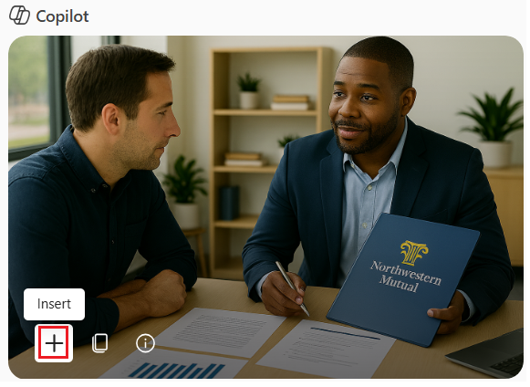
- Select the Overview section in the document.
- Use the following prompt.
Prompt 6: “Rewrite this paragraph to make it clearer and easier to understand.”
